World Book Day – Thursday 7th March 2024

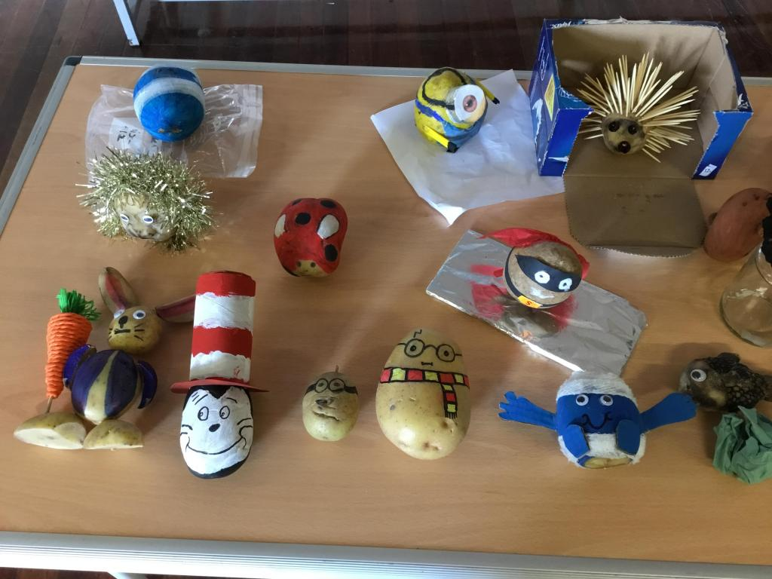
Decorate a potato!

Decorate a potato to be your favourite book character. A prize in each class will be awarded for the best potato!

Whole School Story

A story will be started and passed round each class to continue a little bit more of it- the final one will be published in the newsletter!

Guess the character tea party

A scene will be set up of a tea party- in each space there will be clues about who the characters is. The children will have chance to visit the scene and guess the characters who are attending.

Partner reading
During the day, children will be buddied up with another child in the school to have a shared reading time.

